INFO 691: PROTOTYPING THE USER EXPERIENCE

October 14, 2024

Low Fidelity Storyboarding

and

Mid-Fidelity Wireframing

Team 7: Adesewa Adesida, Brandon Brofsky, Harrison Pauwels, Leyah Winter

**Introduction**

*Design Challenge: Restaurant Automation System*

In this assignment, we develop a series of illustrations that represent the user experience with a system that automates the process of visiting a restaurant. In this system, servers will still physically bring the food and cooks will prepare it, but our design will make all other aspects of the restaurant experience electronic, from being seated at a table, to ordering, to payment. By using both storyboards and wireframes, we will move between different aspects of the user experience while also incorporating feedback to improve our prototype.

**Product Description**

The purpose of this restaurant automation system is to streamline and modernize the dining experience by allowing diners to manage most interactions electronically. Diners can view available tables, make reservations, place orders directly through the system, request assistance, and pay for their meals using different payment methods. The system reduces the need for staff to handle routine tasks, improving efficiency for both diners and restaurant staff.

Key Features:

1. Diners can view vacant tables and reserve/occupy them
2. Diners browse and order from the menu at any time during their visit
3. Cooks receive orders in real-time
4. Servers deliver food once ready
5. Diners can signal for help at any point
6. Multiple payment options available
7. Alerts for staff when tables need to be cleaned
8. Diner leaves review after dining

**Storyboards**

**Leyah**

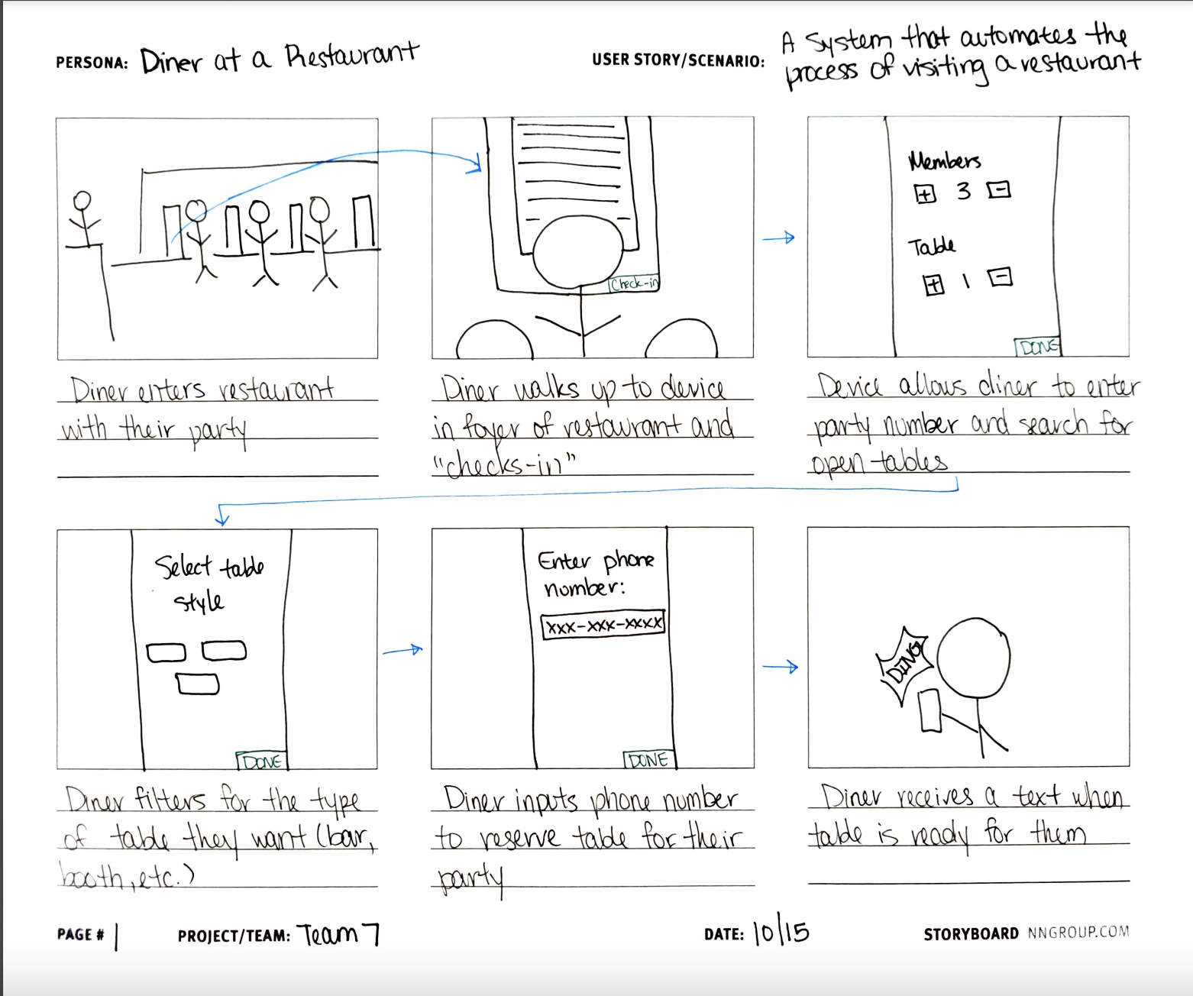

1. **Diners can find/see vacant tables and reserve or occupy them**
2. Diner enters restaurant with their party
3. Diner walks up to device in foyer of restaurant and “checks in”
4. Device allows diner to enter party number and search for open tables
5. Diner filters for the type of table they want (bar, booth, etc.)
6. Diner inputs phone number to reserve table for their party
7. Diner receives a text when table is ready for them

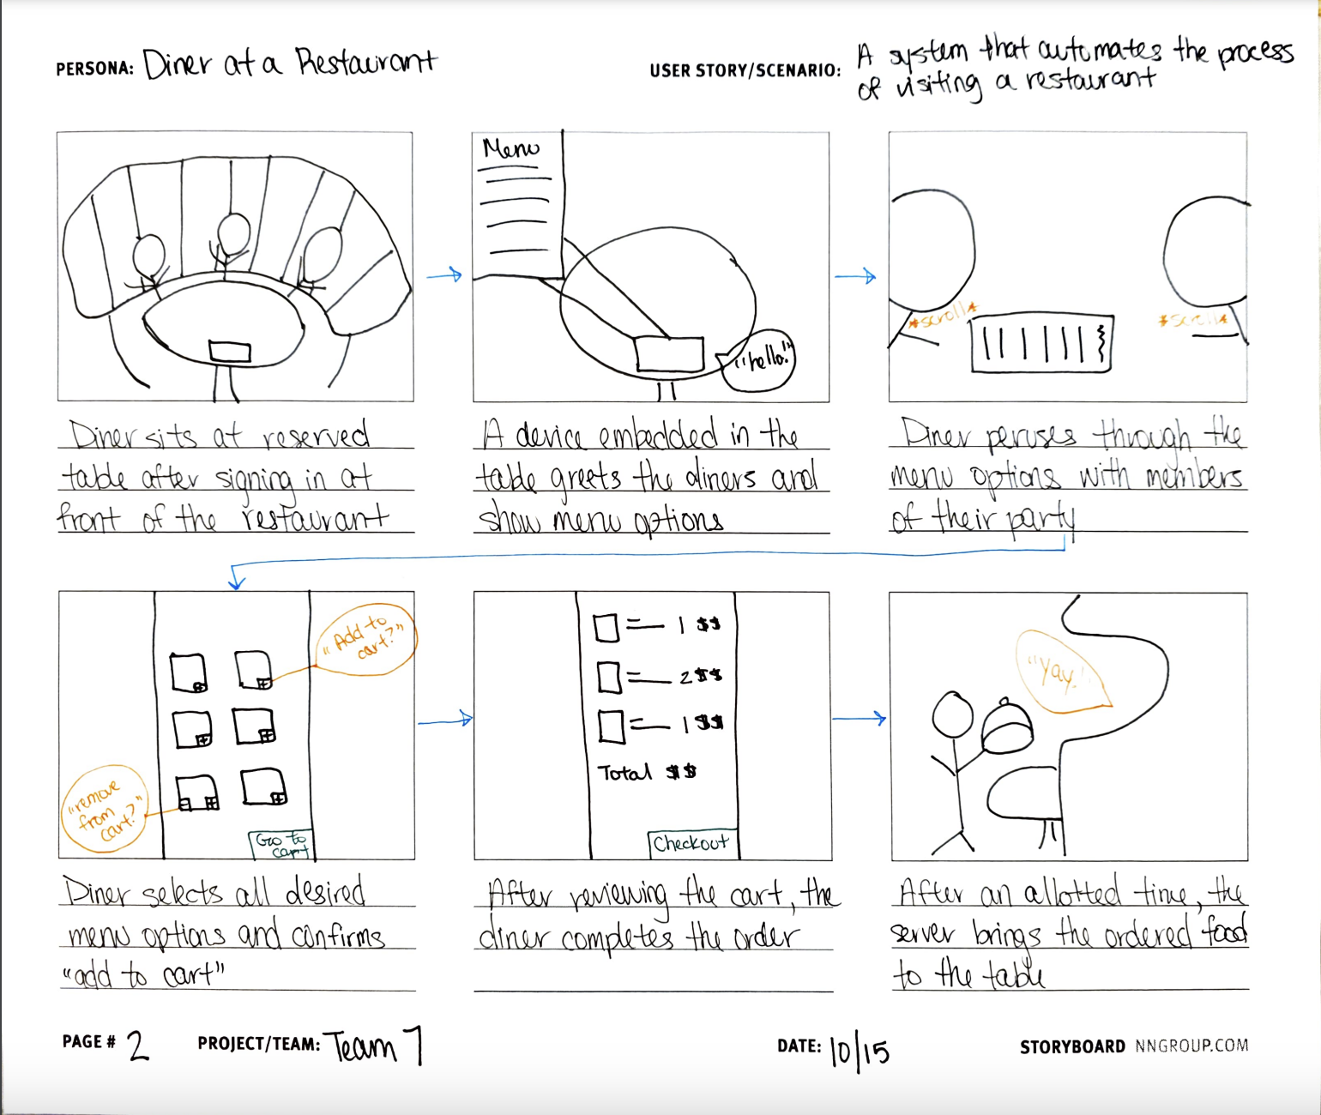

1. **Diners can browse the menu and enter their order at any time throughout their visit**
2. Diner sits at reserved table after signing in at front of the restaurant
3. A device embedded in the table greets the diners and shows menu options
4. Diner peruses through the menu options with members of their party
5. Diner selects all desired menu options and confirms “add to cart”
6. After reviewing the cart, the diner completes the order
7. After an allotted time, the server brings the ordered food to the table

**Adesewa**

* **Storyboard Step: Cooks Receive Orders**
* **Step 1: Order Submission**
* A diner selects their food items using the digital menu on the app or table-side kiosk.
* They press “Submit Order.”
* The system processes the order and sends it directly to the kitchen.
* **Device in Use**: Diner's smartphone or kiosk.
* **Step 2: Order Appears in Kitchen**
* In the kitchen, the cook has a tablet or screen displaying all incoming orders.
* The new order pops up on the screen in real-time, listing the specific items ordered by the diner, along with any special instructions (e.g., dietary restrictions or customizations).
* **Device in Use**: Kitchen display screen or tablet.
* **Step 3: Cook Prepares Order**
* The cook reviews the order and begins preparing the dishes.
* Once each item is completed, the cook marks it as “Ready” on the kitchen display.
* **Device in Use**: Kitchen display (to update the order status).

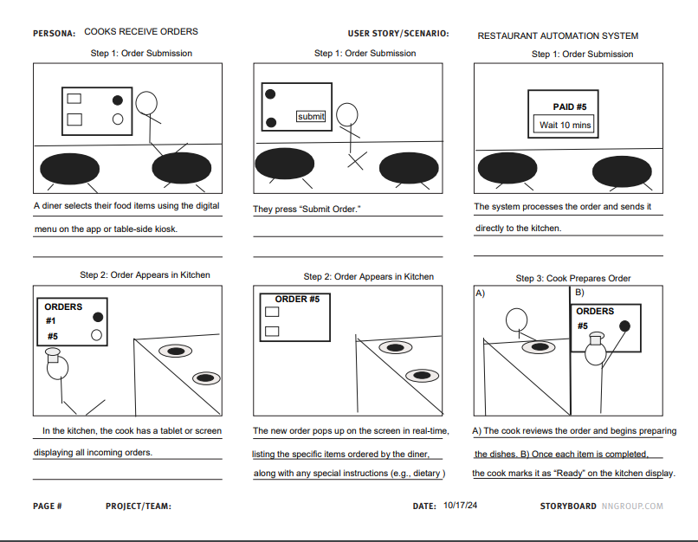

* **Storyboard Step: Servers Deliver Orders**
* **Step 1: Server Notification**
* Once the cook marks the order as “Ready,” a notification is sent to the server’s tablet or smartphone, showing that the diner’s food is ready for delivery.
* The server sees the table number and the details of the order on their device.
* **Device in Use**: Server’s tablet or smartphone.
* **Step 2: Server Retrieves the Order**
* The server heads to the kitchen, checks the kitchen display or tablet to confirm the order details, and collects the food.
* **Device in Use**: Kitchen display for order confirmation.
* **Step 3: Delivering Food to the Table**
* The server brings the prepared food to the appropriate table.
* The server asks if the diners need anything else and marks the order as “Delivered” in the system.
* **Device in Use**: Server’s tablet or smartphone.
* **Step 4: Post-Delivery**
* After delivering the food, the system waits for further interaction, such as additional orders, requests for assistance, or the final payment.
* **Device in Use**: None for this step, unless further requests are made.

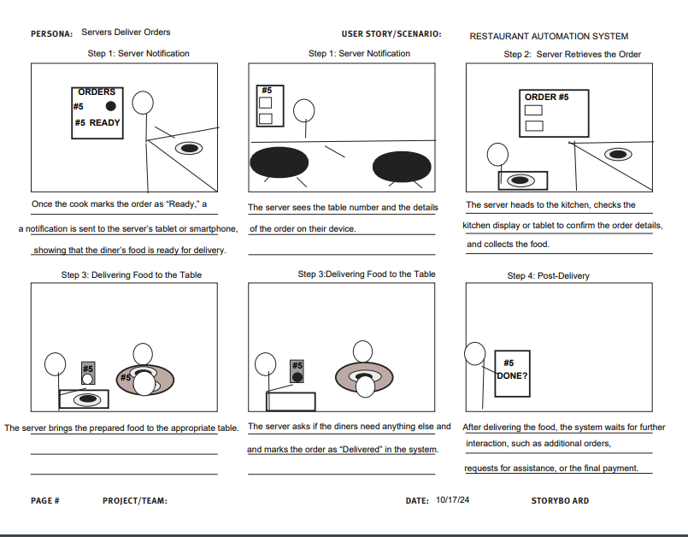

**Brandon**

* Diners can signal a need for help at any point in the process

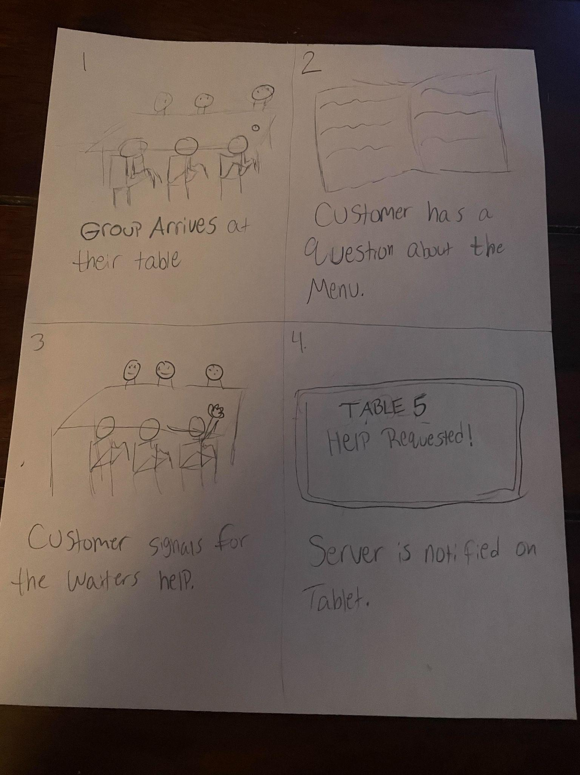

* Diners can pay for their order using different options

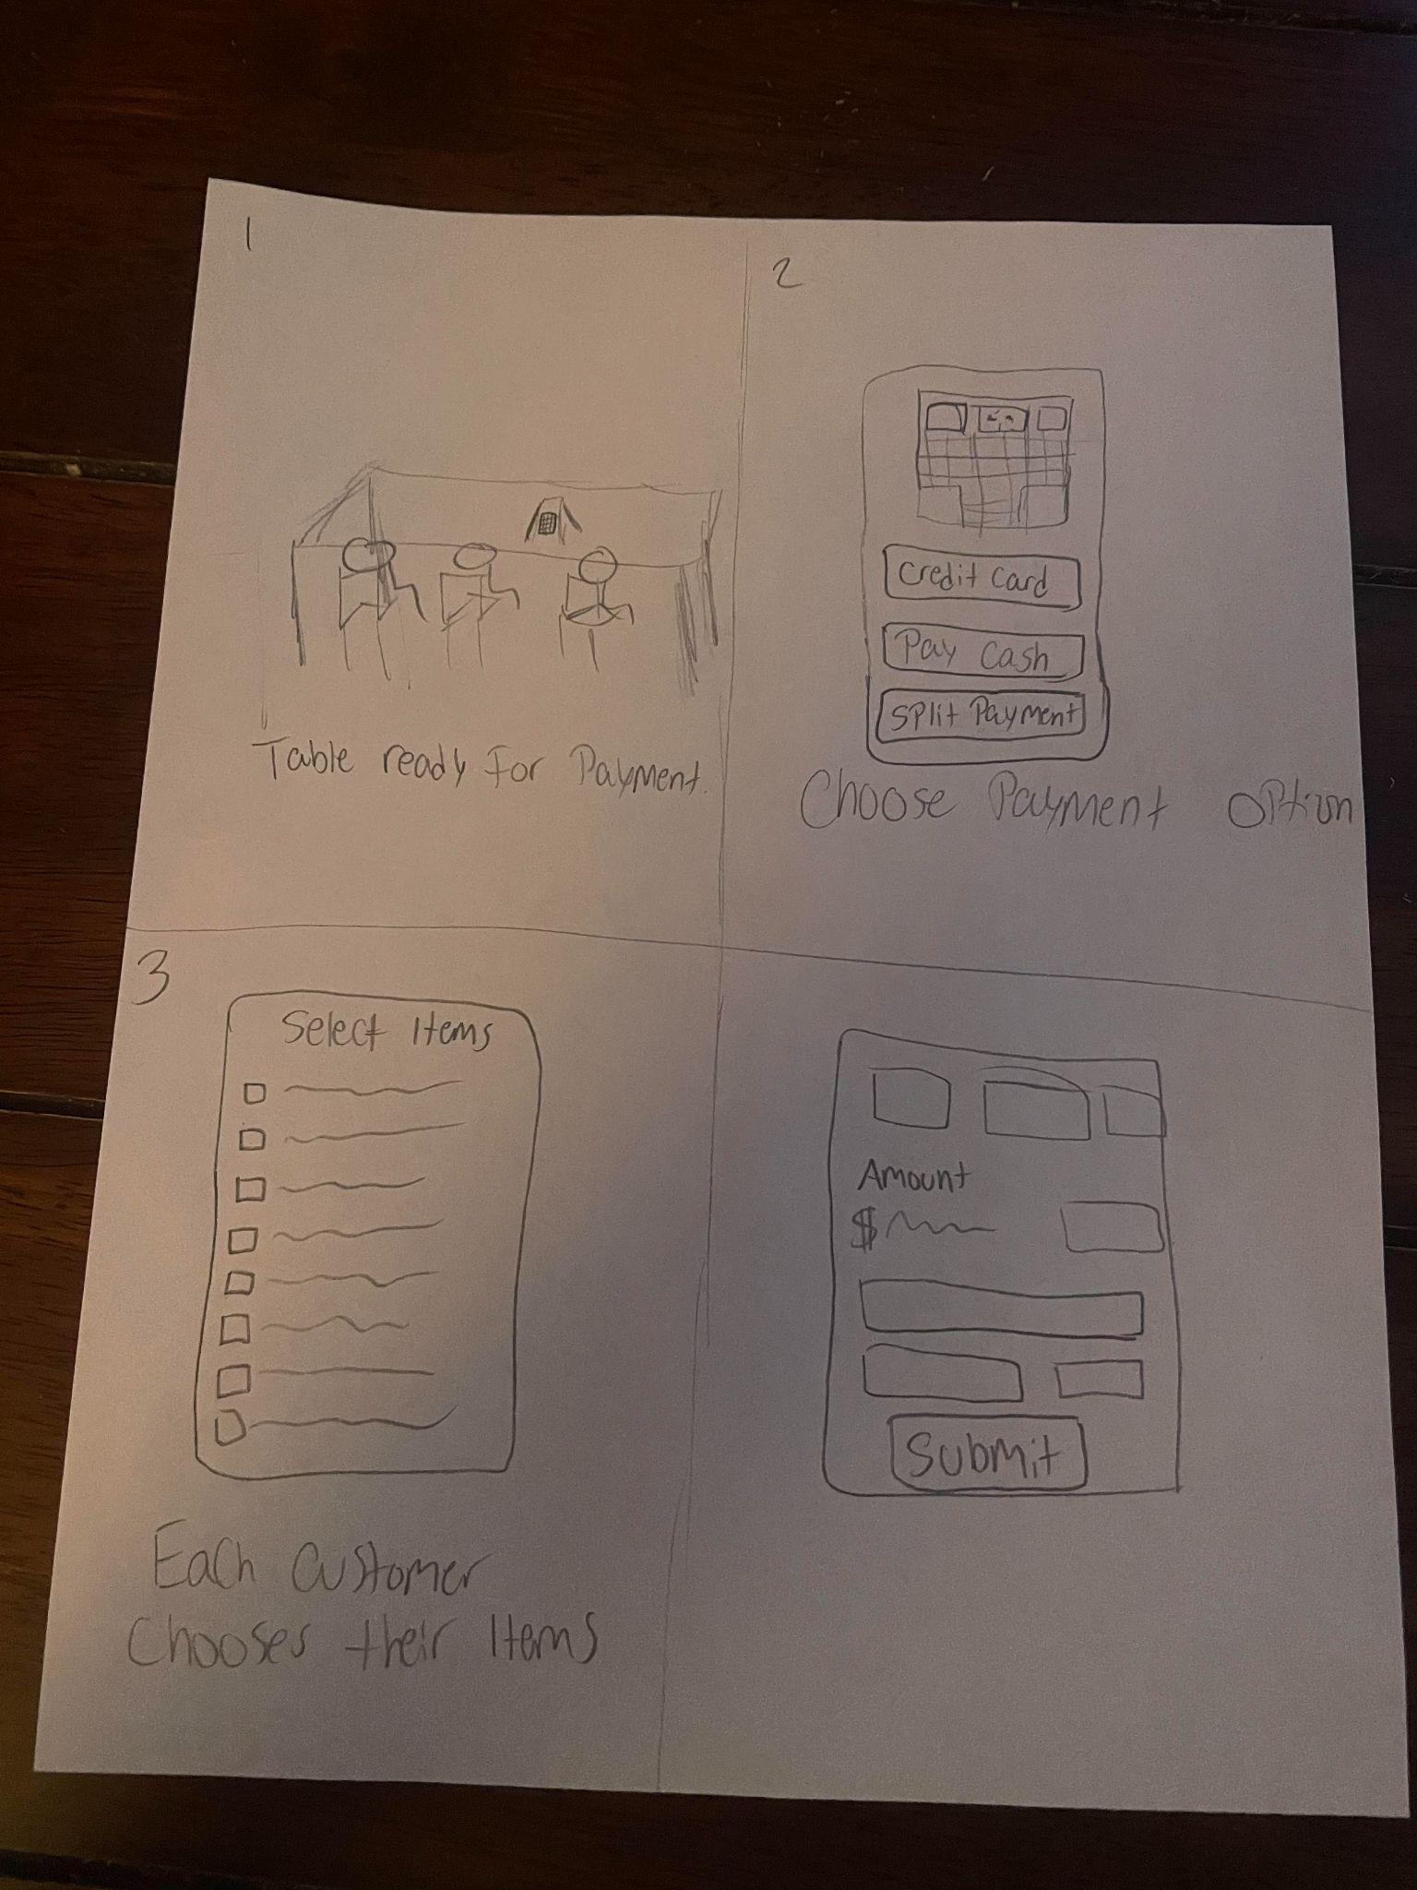

**Harrison**

* Staff are alerted to tables that need bussing

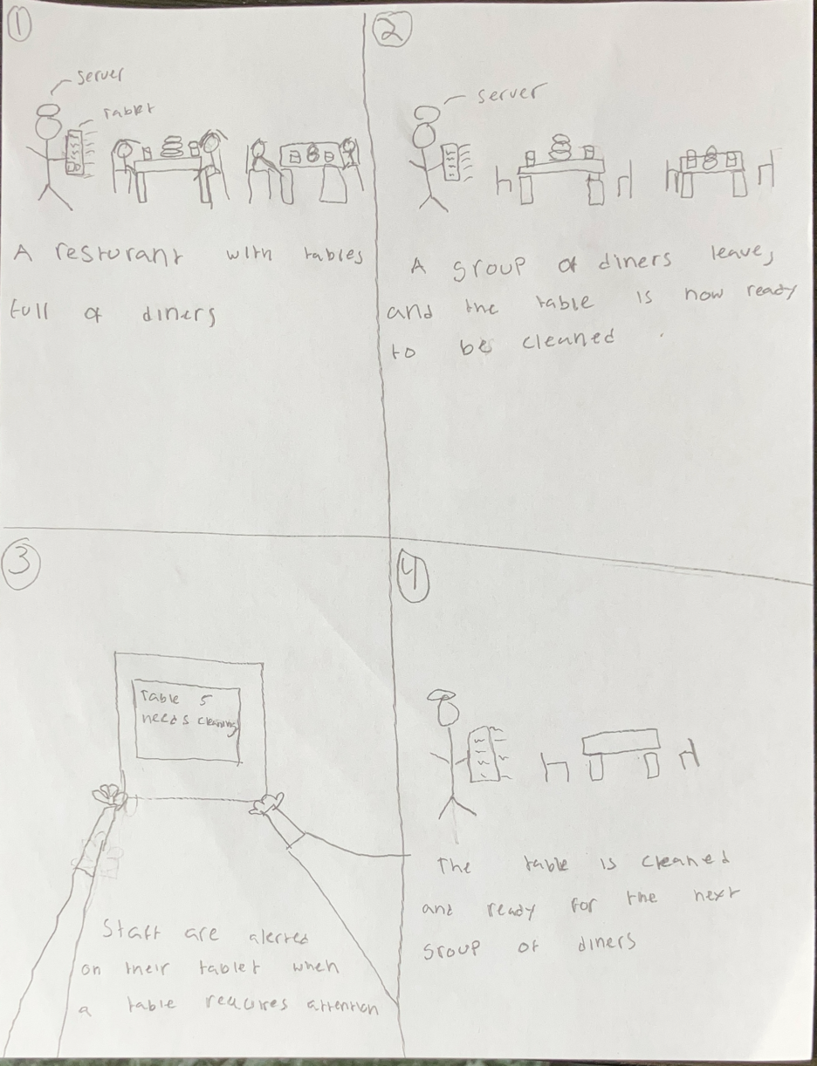

* Diner leaves review after dining

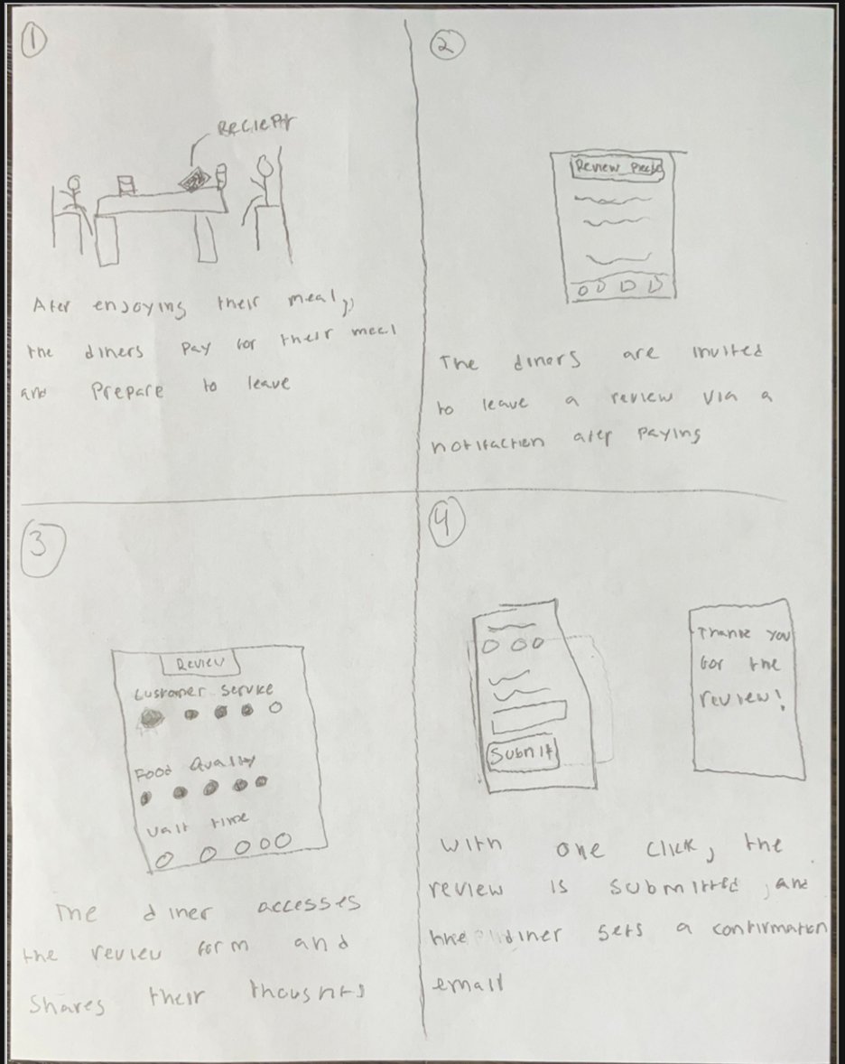

**Feedback (Harrison, Adesewa)**

**Feedback from Will (28, male)**

Overall, I really liked the storyboards and how they showed the flow of this restaurant system. The whole idea of making the dining experience more efficient and giving diners more control—like finding a table, ordering, and asking for help—really makes sense. It feels like something I’d appreciate in a busy place where waiting for service can get frustrating.

I really love the idea behind making the dining experience more efficient, especially with the feature where diners can easily find and reserve tables. It just feels so convenient, particularly when the restaurant is busy, and waiting for a table can be frustrating. That said, the process of checking in, entering the party size, and then filtering for table types seems like a bit much. I think it would be awesome if the system could just suggest available tables based on your party size right away, skipping the need to manually filter for the type of table.

As for the feature where diners can signal for help, I think it’s such a smart way to avoid the awkwardness of trying to flag down a server. It gives diners more control, which is awesome, and would definitely make the service feel more responsive. My only suggestion here would be to make sure the system is really easy to use, like with a quick tap on the screen or mobile app, so it feels natural and not like an extra task when you’re just trying to enjoy your meal.

**Feedback from Chidera Onouha**

The storyboards for the restaurant automation system do a great job of showing how diners and staff interact with the system. It’s easy to follow the steps for reserving tables, ordering food, and paying. The feature that lets diners ask for help when needed is a great addition, making the dining process feel smoother and more efficient.

However, the table reservation process could be simpler. Instead of filtering for table types, the system could automatically suggest tables based on the number of people. Making the system easier to use, especially for asking for help, will ensure diners have a more seamless experience.

Overall, the team has designed a solid system, and with a few tweaks, it can be even more user-friendly.

**Wireframes (Brandon, Leyah)**

**Action 5:** Diners can signal a need for help at any point in the process

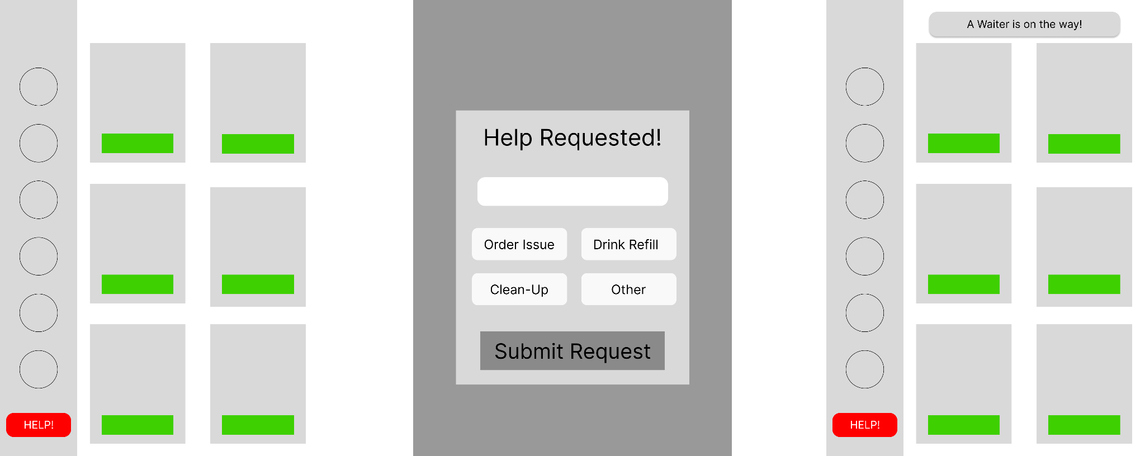

**Action 1:** Diners can find/see vacant tables and reserve or occupy them

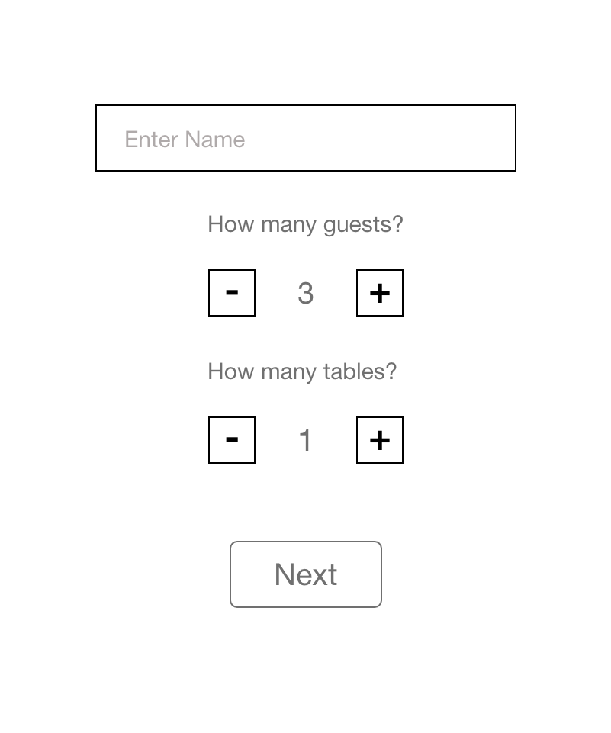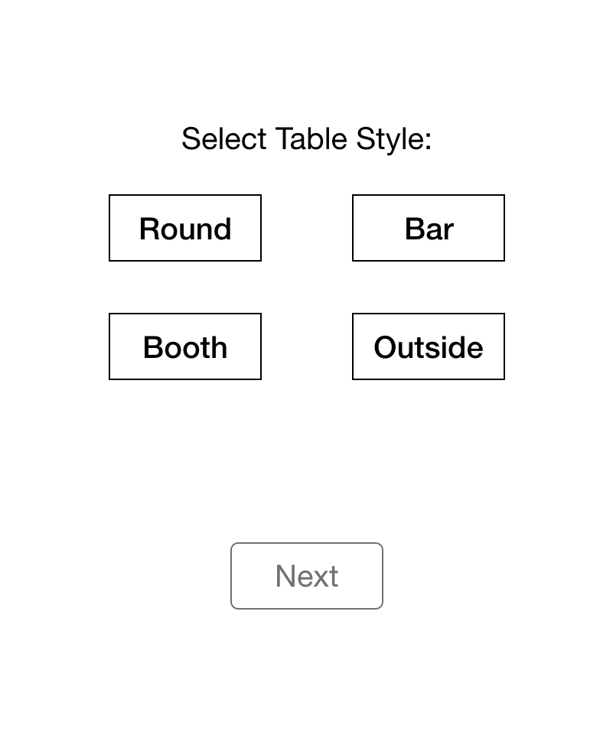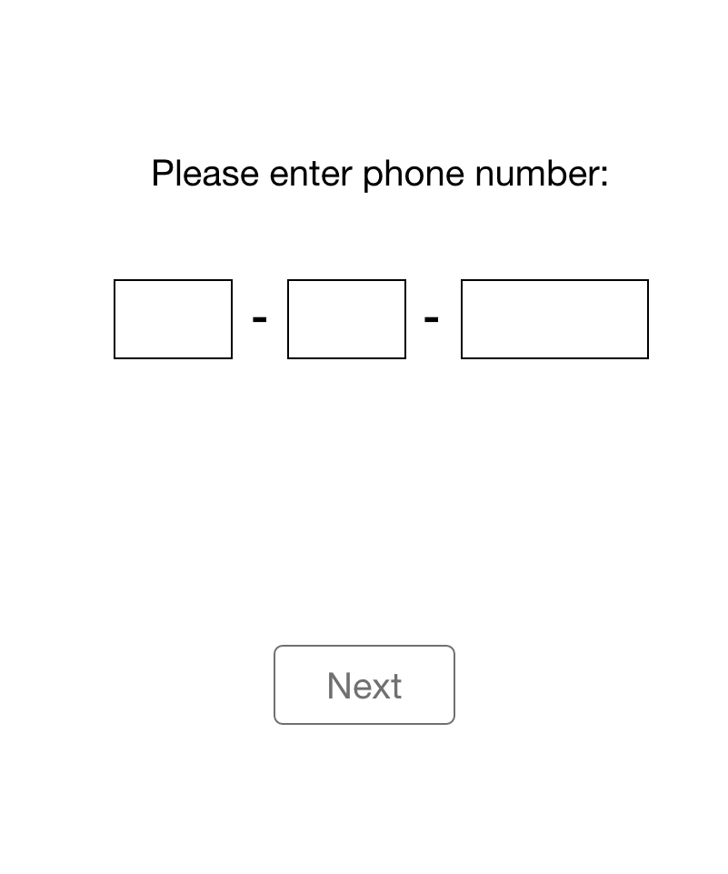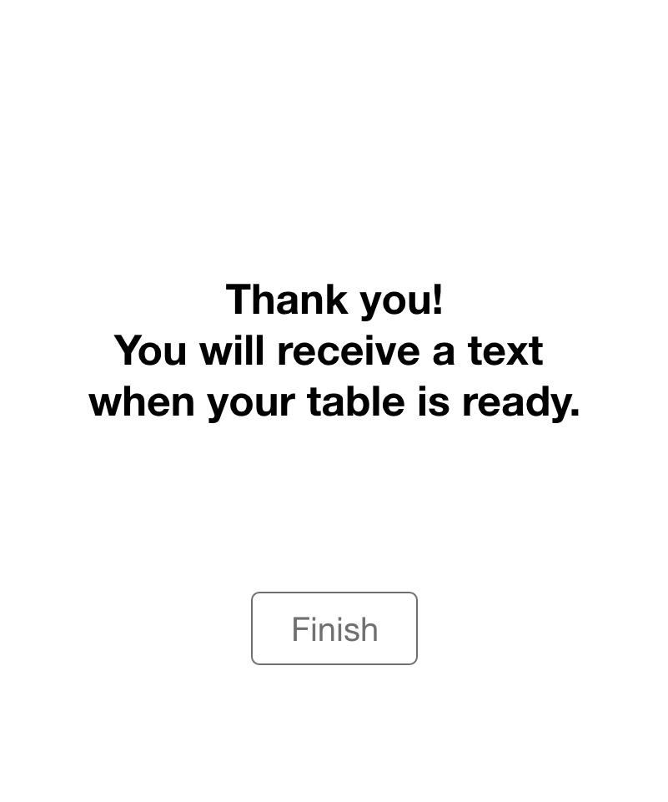

**Design Justification**

Our team started our process with storyboarding several scenarios for this semi-automated restaurant. Storyboarding helped us to pinpoint two distinct designs that we felt would be most impactful in showcasing the most vital features of this restaurant. Then, we gathered feedback from two people on the two designs. After gathering feedback, we finally proceeded to create two wireframe designs based off the following scenarios:

* **Diners can find/see vacant tables and reserve or occupy them**
* **Diners can signal for help at any point**

Our team decided that these two scenarios would be the best to utilize in wireframing because our feedback results illustrated that people like the convenience of asking for help and support in a timely manner. It may also help people who have a hard time getting the attention of their servers. We felt that the entire design process, from storyboarding to gathering feedback to initial wireframing was fairly straight-forward and simple considering that we were able to divide out the work equally between the group members. As for the user feedback, it seems that users want as seamless a system as possible for communicating with restaurant employees when necessary as well as a clean and simplistic design. This affected our design in the way that we prioritized keeping minimal yet informative content on the wireframes, being careful not to crowd the screen with unnecessary information.